Nakayoshi Gakko
Arts and Crafts Committee

Class: Kuma
Pick up Board

Project: Garden Diorama

Material: (1) 1/4" x 2' x 4' Wood Board, Sandpaper

Qty. Needed: (18) 8" x 8" pieces

Instructions: Cut each piece of wood into (18) 8" x 8" pieces. (See diagram) Please sand so there are no rough edges.
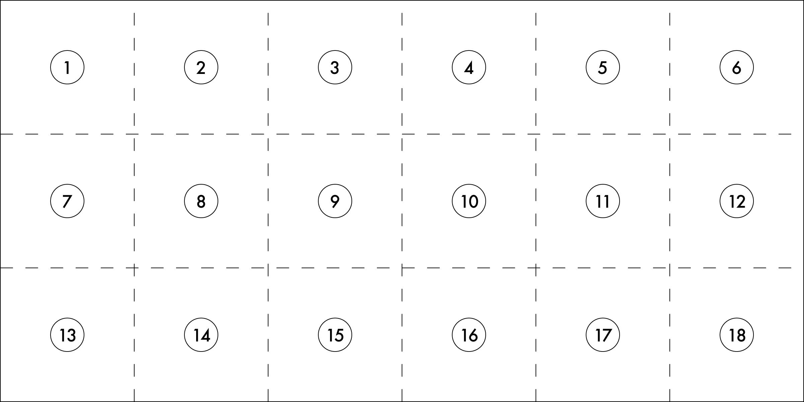

Due Date: Bring completed project with you on Maintenance I Day prior to the start of session. Please return any leftover material.

Thank you in advance for your help.

